
TELEKOMMUNIKATSIYA TEXNOLOGIYALARI FAKULTETI
UrDU
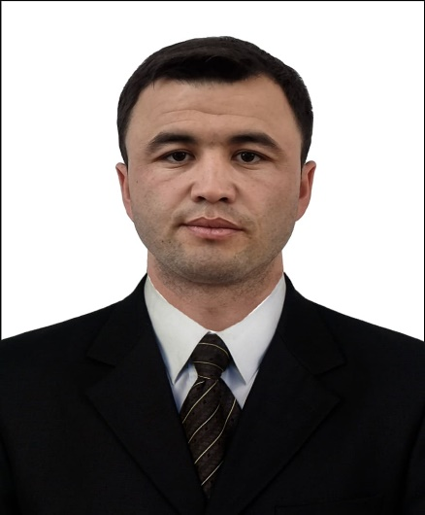 |  | F.I.SH.: Raxmon Saparbayev Komiljonovich  LAVOZIM: Assistent o'qituvchi  TEL: +99894 118-96-61  E – mail: rakhmon_saparbaev@urdu.uz  saparbayevraxmonbergan@gmail.com  TASHKILOT TEL: +99862 2246700
  TASHKILOT MANZILI: | Urganch shahar -Xorazmiy ko'chasi ko‘chasi 110
DARAJASI | - 2016 – 2020 - Muhammad al-Xorazmiy nomidagi Toshkent Axborot Texnologiyalari Universiteti Urganch filiali (bakalavr)  - 2020 – 2022 - Muhammad al-Xorazmiy nomidagi Toshkent Axborot Texnologiyalari Universiteti (magistr)
TAJRIBA | - 2020-2021yy -Toshkent tumani 2-son KHM Raqamli axborotlarni qayta ishlash bo‘yicha o‘qituvchi  - 2021-2022yy -Zangiota Abu Ali ibn Sino nomidagi jamoat salomatligi texnikumi axborot tarmogi adminstratori  - 2022 -2023yy - Muxammad al-xorazmiy nomidagi Toshkent axborot texnologiyalar universiteti Urganch filiali telekommunikatsiya injiniringi kafedrasi stajor – o‘qtuvchisi  - 2023 -2024yy - Muxammad al-xorazmiy nomidagi Toshkent axborot texnologiyalar universiteti Urganch filiali telekommunikatsiya injiniringi kafedrasi stajor – o‘qtuvchisi  - 2024-2025 yy - Muxammad al-xorazmiy nomidagi Toshkent axborot texnologiyalar universiteti Urganch filiali telekommunikatsiya injiniringi kafedrasi assistent – o‘qtuvchisi  - 2025 - h.v. "Abu Rayhon Beruniy nomidagi Urganch davlat universiteti" davlat muassasasi o'qituvchi
MUTAXASISLIGI | - Tеlеkommunikatsiya injiniringi (Axborotlarni uzatish tizimlari)
O‘QITADIGAN FANLARI | - Elektronika va sxemalar; Tarmoqlarni modellashtirish va simulyasiyalash; IoT: aloqa va protokollar; Elektromagnit maydonlar va to’lqinlar; Tizimlar va signallarni qayta ishlash; Telekommunikatsiya tarmoqlaridagi IoT.
TADQIQOT ISHI | - Telekommunikatsiya tarmoqlarida viruslarning tarqalish jarayonlarini modellashtirish
ILMIY TADQIQOTLARI | - Jumanazarov, D., Atamurotov, F., Xudoynazarov, E., Matyokubov, K., Saparbaev, R., Abdikarimov, X., & Olsen, U. L., "Method for the Correction of Spectral Distortions in X-Ray Photon-Counting Detectors," in IEEE Transactions on Instrumentation and Measurement, vol. 74, pp. 1-15, 2025, Art no. 6001315, https://doi.org/10.1109/TIM.2025.3529057  - Olimboy Olimov; Ibratbek Omonov; Raxmon Saparbayev; Davlatbek Matyakubov; Vohid Kuchkarov. Multi-use models of channel resources of LTE technology. AIP Conf. Proc. 3331, 030044 (2025) https://doi.org/10.1063/5.0305924  - Rakhman Saparbayev, Isroiljon Makhmudov, Mukhiddinjon Tillaboev, Boburjon Vafoev. Modeling of Virus Spread Processes in Telecommunication Networks. ICFNDS '24: Proceedings of the 8th International Conference on Future Networks & Distributed Systems Pages 1072 - 1077 https://doi.org/10.1145/3726122.3726294  - Saparbayev R. K., Olimov O. O. Finite impulse response (fir) filtering analysis of signals using matlab software //SCHOLAR. – 2024. – Т. 2. – №. 2. – p. 61-66...  - Olimov O. O., Saparbayev R. K. Network traffic queue analysis //Educational Research in Universal Sciences. – 2024. – Т. 3. – №. 2. – p. 311-318.  - N.Y. Ye, R.K. Saparbaev, I.I Omonov . A brief review of machine learning algorithms O’zbekistonda Fanlararo Innovatsiyalar va Ilmiy Tadqiqotlar Jurnali, 2 (15) (2023), pp. 411-417.  - Saparbaev Rakhmon, ANALOG TO DIGITAL CONVERSION PROCESS BY MATLAB SIMULINK // Muhammad al-Xorazmiy nomidagi TATU Farg‘ona filiali “Al-Farg‘oniy avlodlari” elektron ilmiy jurnali ISSN 2181-4252 Tom: 1 | Son: 4 | 2023-yil  - Masharipov O. M.,Kuchkarov V.A.,Saparbayev R.K., "Optik tolali tizimlarning ishonchlilik parametrlarini oshirish usullari "Xorazm axborot texnologiyalari jurnali Nashr qilingan sana: 2025-11-15  - K.E.ONARKULOV ,I.A.MAKHMUDOV, SH.M. TOSHPULATOV, F. M.TOSHPULATOVA, R.K.SAPARBAEV, O.O.OLİMOV.," Artifiial Intelligence-Based Diagnostic Analysis of Oncohematological Diseases 9th International Conference on Engineering Technologies ICENTE 2025 20-22 November 2025 Proceedings Book

