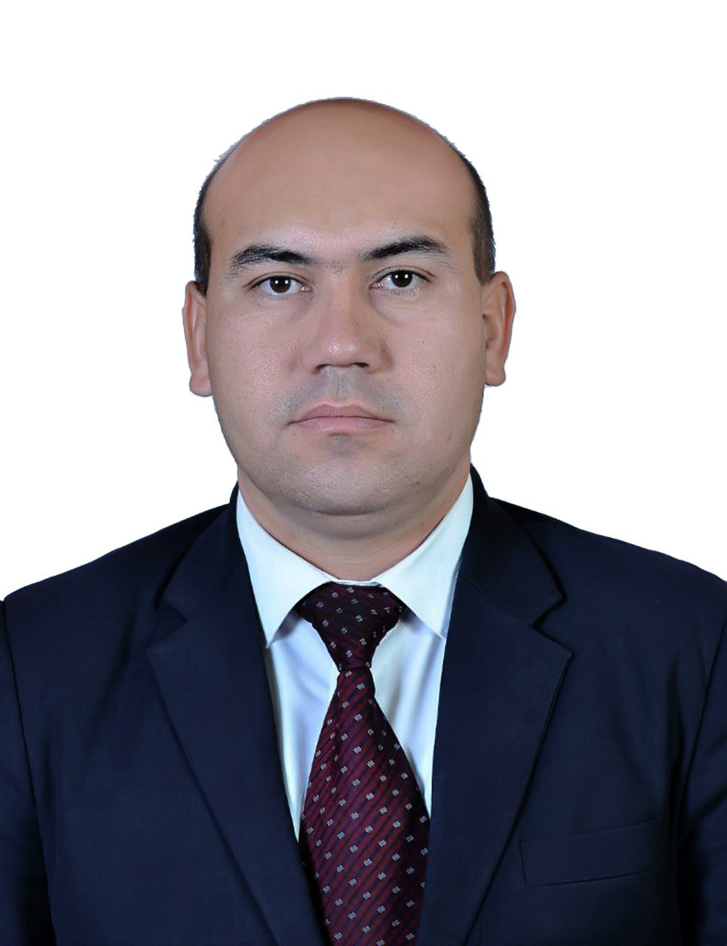 | FULL NAME: Duschanov Umar Egamberdiyevich.  POST. Deputy Dean of the Faculty of Bioengineering and Food Safety. Lecturer at the Department of Soil Science and Agronomy.  PHONE NUMBER.+998939221884  E-mail. mr.umar17@mail.ru  ORGANIZATION’S PHONE NUMBER. +99862 2246700  ORGANIZATION ADDRESS. 220100, Khorezm region, Urgench city, H.Alimdjon str.,14
LEVEL | - 2020- until now Deputy Dean for Youth Affairs,Faculty of Bioengineering and Food Safety, Urgench State University.  - 2015-2017 Lecturer at the Department of Soil Science and Agronomy (from September2, 2015 Deputy Dean of the Facultyof Natural Sciences on a part-time basis (spiritual and enlightenment work on affairs)  - 2012-2015 .Lecturer at the Department of Sustainable Development and Environmental Education, Urgench State University. (2013 ,Deputy Dean of the Faculty of Natural Sciences and Geography on a port-time basis ( spiritual and enlightenment work on affairs))  - 2010-2012 . Master, Urgench State University  - Bachelor, Tashkent State Agrarian University
WORK EXPERIENCE | - 2020- until now Deputy Dean for Youth Affairs,Faculty of Bioengineering and Food Safety, Urgench State University.  - 2019-2020 . Deputy Dean for Youth Affairs, Faculty of Natural Sciences, Urgench State University.  - 2017-2019. Deputy Dean for Spiritual and Enlightenment Affairs, Faculty of Natural Sciences , Urgench State University  - 2015-2017 . Lecturer at the Department of Soil Science (from September2, 2015 Deputy Dean of the Facultyof Natural Sciences on a part-time basis (spiritual and enlightenment work on affairs)  - 2012-2015 .Lecturer at the Department of Sustainable Development and Environmental Education, Urgench State University. (2013 ,Deputy Dean of the Faculty of Natural Sciences and Geography on a port-time basis ( spiritual and enlightenment work on affairs))  - 2010-2012 . Master, Urgench State University  - 2008-2010 . Head of the laboratory of the Faculty of Natural Sciences of Urgench State University.  - 2006-2008 йй. Urgench entrepreneur car tractor park assistant director.
SPECIALIZATION | - Agronomy,Bioecology
SUBJECTS | - Basics of animal husbandry and silkworm breeding, basic of agricultural research, Botany
RESEARCH WORK | “fauna and ecology of hard-winged birds in the agrocenoses of Khorezm region ”
PUBLICATION | • Полиз агроценози энтомофаунаси ва қовун пашшаси (Myiopardalispardalina) нинг биоэкологияси (монография). Хоразм нашриёти 2011 йил Х.У Бекчанов. Н Ядгарова  • Экологик изохли луғат. Хоразм нашриёти 2013 йил Р.Эгамбердиев, Д.Махмудова  • Сабзавотчилик (услубий қўлланма). Адабиёт учқунлари 2016 йил. А.Таджиев, А.Машарипов, С.Саъдуллаев  • Дехқончилик илмий изланиш асослари билан (услубий қўлланма). Адабиёт учқунлари 2016 йил. А.Таджиев, А.Машарипов, Ш.Бабажанова, Р.Рўзметов  • Боғ зараркунандаларига қарши самарали кураш тизими. УрдУ “Магистрларнинг илмий ва илмий методик мақолалари тўплами” Урганч 2009 й. Ш.Халиллаев  • Хонқа ва Янгибозор туманларида тарқалган бошоқли дон экинлари зараркунандалари. УрдУ “Қишлоқ тараққиёти ва фаровонлиги” йилига бағишланган илмий амалий анжумани материаллари. 2009 й. Н.С.Ядгарова, М.Рўзметова  • Қишлоқ хўжалик экинлари зараркунандалари энтомофаглари. Хоразм Маъмун академияси Ахборотномаси. 2012- й 2-сон И.И.Абдуллаев  • Biodiversity of Coleopteran Insects (Insecta, Coleoptera) in the  Tugai Forests of the Lower Amudarya State Biosphere Reserve  (Қуйи Амударё давлат биосфера қўриқхонасининг Тўғай ўрмонларида Coleoptera хашаротларнинг биологик хилма-хиллиги (Insecta, Coleoptera) ). International Journal of Academic and Applied Research (IJAAR). ISSN: 2643-9603. Vol. 4 Issue 11, November - 2020, (Халқаро академик ва амалий тадқиқотлар журнали (IJAAR) ISSN: 2643-9603 (онлайн) ) Х.У.Бекчанов, Г.Қ.Комилжонова  • Фауна Жесткокрылиых (Insecta, Coleoptera) Хорезмского Оазиса. Хоразм Маъмун Академияси Ахборотномаси 2021 йил Январ №1 сон. Х.У.Бекчанов, Г.Қ.Комилжонова  • Жуки семейства жужелицы (insecta coleóptera carabidae) нижне-амударьинский государственный биосферный резервата и предельных районах. ACADEMIC RESEARCH IN EDUCATIONAL SCIENCES VOLUME 2 | ISSUE 1 |2021 ISSN: 2181-1385 Scientific Journal Impact Factor (SJIF) 2021: 5.723(1171-1178 бетлар) Х.У.Бекчанов, З.Р.Шодиев
CURRENT  RESERCH | Фауна Жесткокрылиых (Insecta, Coleoptera) Хорезмского Оазиса. Хоразм Маъмун Академияси Ахборотномаси 2021 йил Январ №1 сон. Х.У.Бекчанов, Г.Қ.Комилжонова.  • Жуки семейства жужелицы (insecta coleóptera carabidae) нижне-амударьинский государственный биосферный резервата и предельных районах. ACADEMIC RESEARCH IN EDUCATIONAL SCIENCES VOLUME 2 | ISSUE 1 |2021 ISSN: 2181-1385 Scientific Journal Impact Factor (SJIF) 2021: 5.723(1171-1178 бетлар) Х.У.Бекчанов, З.Р.Шодиев

