
FACULTY OF PHYSICS AND MATHEMATICS
UrSU
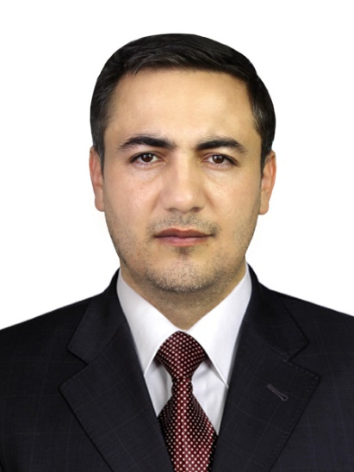 |  | NAME: Doniyor Jumanazarov  POSITION: Associate professor, DSc  TEL: +99899 567-13-21  E – mail: doniju@urdu.uz  doniyor.jumanazarov@fysik.dtu.dk  ORGANISATION TEL: +99862 2246700  ORGANISATION ADRESS: Urgench, Kh.Olimjan str, 14, 220100
EDUCATION: | - 2008 – 2012 - National University of Uzbekistan (bachelor)  - 2016 – 2018 - École normale supérieure (ENS) Paris-Saclay University, Cachan, France (master degree)  - 2018 – 2022- Ph.D., Department of Physics, Technical University of Denmark, Denmark
CAREER / EMPLOYMENT: | - 2012– 2013 Physics teacher, Academic lyceum of Computer Technologies under the Tashkent State Technical University, Tashkent, Uzbekistan  - 2013–2014 Physics teacher, Khazorasp Pedagogy and Service College, Khorezm, Uzbekistan.  - 2014–2015 Physics teacher, Khazorasp Agricultural Professional College, Khorezm, Uzbekistan.  - 2015–2016 Physics teacher, Academic lyceum of Computer Technologies under the Tashkent State Technical University, Tashkent, Uzbekistan.  - 2016–2022 Study for master degree and PhD.  - 2022–present, Associate professor at the Department of Physics, Urgench State University, Uzbekistan.
SPECIALITY | - Physics of condensed matters, Solid state physics, Material science.
TEACHING SUBJECTS: | - General Physics; Termodynimics and statistical physics; Nuclear medicine; Physical basis of medical technique; Application of accelerators in medicine; Physical basis of PET, MRI and CT scans; Nanophysics.
RESEARCH AREAS OF INTEREST: | - X-ray Physics; X-ray Computed Tomography (CT); Image reconstruction; Materials Characterization; Data analysis; Photon-counting detectors; Security, medical and industrial applications.
LIST OF SELECTED PAPERS | - Sabirov, K., Jumanazarov, D., Yusupov, J., & Matrasulov, D. (2018). Bogoliubov de gennes equation on metric graphs. Physics Letters A, 382(39), 2856–2860. doi: https://doi.org/10.1016/j.physleta.2018.06.016.  - Jumanazarov, D., Koo, J., Busi, M., Poulsen, H. F., Olsen, U. L., & Iovea, M. (2020). System-independent material classification through X-ray attenuation decomposition from spectral X-ray CT. NDT and E International, 116(July), 102336. doi: 10.1016/j.ndteint.2020.102336.  - Jumanazarov, D., Koo, J.-K., Poulsen, H. F., Olsen, U. L., & Iovea, M. (2021). The significance of the spectral correction of photon counting detector response in material classification from spectral x-ray CT. Quantum Optics and Photon Counting 2021, SPIE, 11771(April), 60–76. doi:10.1117/12.2589290.  - Jumanazarov, D., Koo, J., Poulsen, H. F., Olsen, U. L., & Iovea, M. (2022). Significance of the spectral correction of photon counting detector response in material classification from spectral x-ray CT. Journal of Medical Imaging, 9(3), 1–24. doi: 10.1117/1.JMI.9.3.034504.  - Jumanazarov, D., Koo, J., Kehres, J., Poulsen, H. F., Olsen, U. L., & Iovea, M. (2022).Material classification from sparse spectral X-ray CT using vectorial total variation based on L infinity norm. Materials Characterization, 187, 111864. doi: 10.1016/j.matchar.2022.111864.  - Jumanazarov, D., Alimova, A., Abdikarimov, A., Koo, J., Poulsen, H. F., Olsen, U. L., & Iovea, M. (2023). Material classification using basis material decomposition from spectral x-ray ct. Nuclear Instruments and Methods in Physics Research Section A: Accelerators, Spectrometers, Detectors and Associated Equipment, 1056, 168637. doi:10.1016/j.nima.2023.168637.

