
FIZIKA-MATEMATIKA FAKULTETI
UrDU
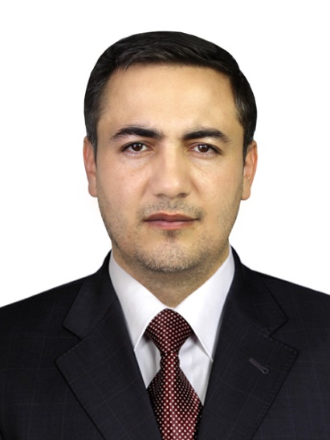 |  | F.I.SH.: Doniyor Jumanazarov Rustamovich  LAVOZIM: Kafedra dotsenti, DSc  TEL: +99899 567-13-21  E – mail: doniju@urdu.uz  doniyor.jumanazarov@fysik.dtu.dk  TASHKILOT TEL: +99862 2246700  TASHKILOT MANZILI: Urganch shahar Xamid Olimjon ko‘chasi 14, 220100
DARAJASI | - 2008 – 2012 – O’zbekiston Milliy Universiteti (bakalavr)  - 2016 – 2018 - École normale supérieure (ENS) Paris-Saclay Universiteti, Kashan, Fransiya (magistr)  - 2018 – 2022- Ph.D., Fizika Fakulteti, Daniya Texnika Universiteti, Daniya
TAJRIBA | - 2012– 2013 o’qituvchi, Toshkent davlat politexnika universiteti qoshidagi Kompyuter texnologiyalari akademik litseyi, O’zbekiston.  - 2013–2014 o’qituvchi, Hazorasp pedagogika va xizmat ko'rsatish kasb-hunar kolleji, O’zbekiston.  - 2014–2015 o’qituvchi, Hazorasp qishloq xo’jalik kasb-hunar kolleji, O’zbekiston.  - 2015–2016 o’qituvchi, Toshkent davlat politexnika universiteti qoshidagi Kompyuter texnologiyalari akademik litseyi, O’zbekiston.  - 2016–2022 Magistratura va PhD ilmiy darajalari uchun o’qish.  - 2022–hozirgacha, Urganch davlat universiteti Fizika kafedrasi dotsenti, O’zbekiston.
MUTAXASISLIGI | - Kondensirlangan muhitlar fizikasi, Qattiq jism fizikasi, Materialshunoslik.
O‘QITADIGAN FANLARI | - Umumiy fizika; Termodinamika va statistik fizika; Yadro tibbiyoti; Tibbiyot texnikasining fizikaviy asoslari; Tezlatkichlarning tibbiyotda qo’llanilishi; PET, MRT va KT tomografiyalarining fizik asoslari; Nanofizika.
TADQIQOT ISHI | - Rentgen nurlar fizikasi; Rentgen kompyuter tomografiyasi (KT); Tasvirlar rekonstruksiyasi; Materiallar xarakteristikasi; data analiz; foton-sanovchi detektorlar; Tomografiyaning havfsizlik, tibbiyot va sanoatda qo’llanilishi.
ILMIY TADQIQOTLARI | - Sabirov, K., Jumanazarov, D., Yusupov, J., & Matrasulov, D. (2018). Bogoliubov de gennes equation on metric graphs. Physics Letters A, 382(39), 2856–2860. doi: https://doi.org/10.1016/j.physleta.2018.06.016.  - Jumanazarov, D., Koo, J., Busi, M., Poulsen, H. F., Olsen, U. L., & Iovea, M. (2020). System-independent material classification through X-ray attenuation decomposition from spectral X-ray CT. NDT and E International, 116(July), 102336. doi: 10.1016/j.ndteint.2020.102336.  - Jumanazarov, D., Koo, J.-K., Poulsen, H. F., Olsen, U. L., & Iovea, M. (2021). The significance of the spectral correction of photon counting detector response in material classification from spectral x-ray CT. Quantum Optics and Photon Counting 2021, SPIE, 11771(April), 60–76. doi:10.1117/12.2589290.  - Jumanazarov, D., Koo, J., Poulsen, H. F., Olsen, U. L., & Iovea, M. (2022). Significance of the spectral correction of photon counting detector response in material classification from spectral x-ray CT. Journal of Medical Imaging, 9(3), 1–24. doi: 10.1117/1.JMI.9.3.034504.  - Jumanazarov, D., Koo, J., Kehres, J., Poulsen, H. F., Olsen, U. L., & Iovea, M. (2022).Material classification from sparse spectral X-ray CT using vectorial total variation based on L infinity norm. Materials Characterization, 187, 111864. doi: 10.1016/j.matchar.2022.111864.  - Jumanazarov, D., Alimova, A., Abdikarimov, A., Koo, J., Poulsen, H. F., Olsen, U. L., & Iovea, M. (2023). Material classification using basis material decomposition from spectral x-ray ct. Nuclear Instruments and Methods in Physics Research Section A: Accelerators, Spectrometers, Detectors and Associated Equipment, 1056, 168637. doi:10.1016/j.nima.2023.168637.

