Faculty of Technique
UrDU
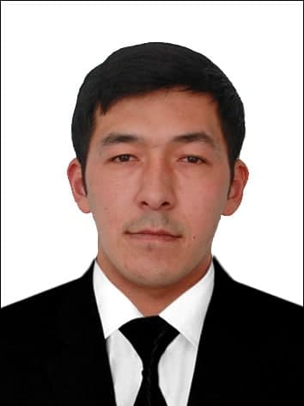
L.N.F.N. Son of Mirzayev Otabek Taxir

Position Intern Reader

ТEL. +998904323205

E-mail lidermirzayev@gmail.ru

ORGANIZATION TEL. +99862 2246700

ORGANIZATION
ADDRESS Urgench city, Hamid Olimjon street, 14, 220100
DEGREE | - 2019-2021 Tashkent State University named after Islam Karimov (Master)  - 2015-2019 Urgench State University (Bachelor)
EXPERIENCE | - From 2021 until now - intern student of the Department of Transportation Systems of Urgench State University  - 2019-2021 yy. – Student of Tashkent vil "Auto-Kurs" LLC enterprise  - 2008-2008 yy. – Recruitment through the employment contract of “deferral Azamat” farm in Gulistan sh/x of Khorezm vil Urgench district.
SPECIALTY | - Testing and use of internal combustion engines
TEACHING DISCIPLINES | - Fundamentals of the theory of internal combustion engines  - Automatic system, ergonomics and design of tractors and agricultural machinery  - Vehicle and tractor automatic Design System, basics of ergonomics and design
RESEARCH | - Improve the side and air transfer system in rare-gas engines
RESEARCHES | - Mirzayev O.T, Normatov M.Q. The effect of diesel on the mixing process of the input pipe shape of the engine sideilg'i mixture. Republican scientific-methodical Journal of educational volunteers № 2 2-volume 2021-y 2-January 860-864 page.  - Mirzayev O.T., Mirzaabdullaev Z.B., Modeling Of The External Speed Characteristic Of A Turbocharged Engine. Islom Karimov Toshkent Davlat Technika Universiteti "Fan technika technika tarokietida intellectual eshlaring srni" zhurlani Toshkent-2021 23-24 April 267-268 bet.
LATEST RESEARCHES | - Improve the side and air transfer system in rare-gas engines

